

**BINUS UNIVERSITY**

**BINUS INTERNATIONAL**

**Assignment Cover Letter**

**(Individual Work)**

|  |  |  |  |  |  |  |  |  |
| --- | --- | --- | --- | --- | --- | --- | --- | --- |
|  | | | | |  | |  | |
| **Student Information**: **Surname** | | | | | **Given Name**  **Wardana** | | **Student ID Number**  **2201798345** | |
| 1. | | **Winson** |  | |
|  |  |
| **Course Code** | **: COMP6502** |  |  | | **Course Name** | | **: Introduction to Programming** | |
| **Class** | **: L1BC** |  |  | | **Name of Lecturer(s)** | | : Monica Hidajat | |
|  |  |  |  | |  | |  | |
| **Major** | **: CS** |  |  | |  | |  | |
| **Title of Assignment**  (if any) | : Jet Fighter(game) | |  |  | |  | |  | |
| **Type of Assignment**    **Submission Pattern** | **: Final Project** |  |  | |  | |  | |
| **Due Date** | **: 20-11-2018** |  |  | | **Submission Date** | | **:** | |

# Plagiarism/Cheating

BiNus International seriously regards all forms of plagiarism, cheating and collusion as academic offenses which may result in severe penalties, including loss/drop of marks, course/class discontinuity and other possible penalties executed by the university. Please refer to the related course syllabus for further information.

# Declaration of Originality

By signing this assignment, I understand, accept and consent to BiNus International terms and policy on plagiarism. Herewith I declare that the work contained in this assignment is my own work and has not been submitted for the use of assessment in another course or class, except where this has been notified and accepted in advance.

Signature of Student: (Name of Student)

1. Winson Wardana

**“Pygame”**

Name : WINSON WARDANA

ID : 2201798345

1. **Description:**

This program is simply designed to make the users to a fun time playing it. It is a simple game you only have to move and shoot the enemy’s jet to get a score.

1. **Discussion:**

**Implementation:**

The things that were included as well as implemented within the program include:

Pygame

Pygame was the main framework to make this project run. Pygame is cross-platform set from python modules designed for writing video games its include all the graphic sound etc.

**How it works:**

Basically there a start menu after your run the program. You can either quit or start the game after you start the game will begin soon. You can move up down left and right and to get many point if you shoot or just dodge the the enemy’s ship and after 600+ point you can level up. There is only 3 lives after that game over.

1. **Evidence**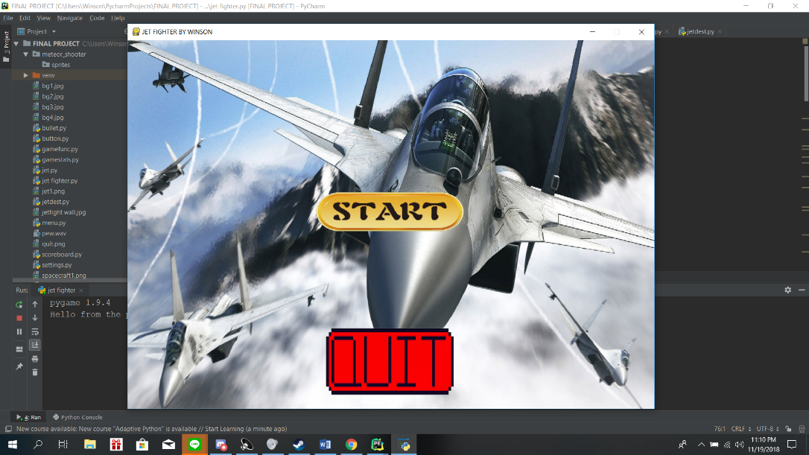

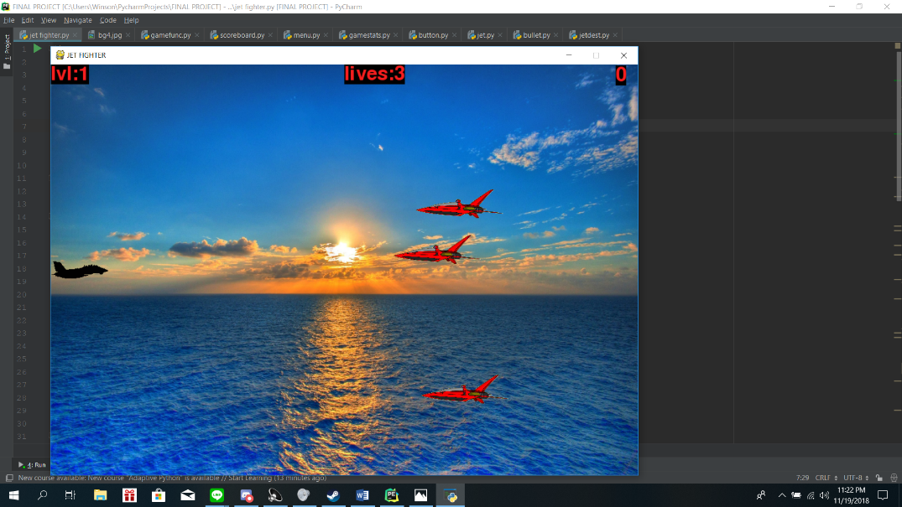

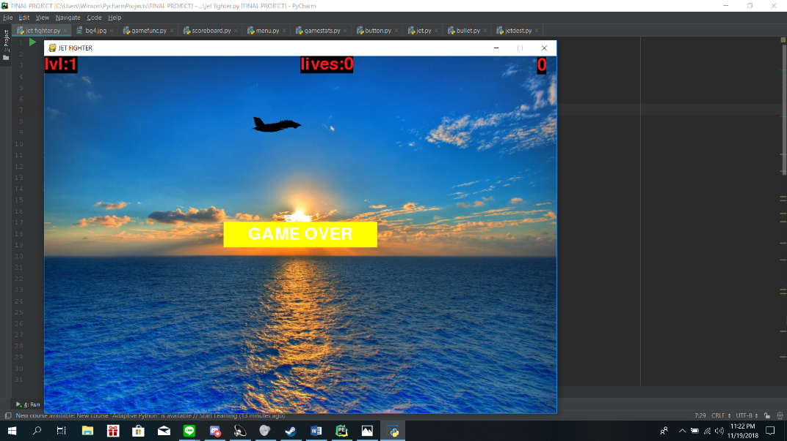

1. **Resource**

**Asoka Wotulo**

**Michael Berlian**

**Python Crash Course:**